**Project Name : Digital Store , Developed by Srikanth Mandula**

-Website is developed using Rails 5.1.1

This is an E-commerce website featuring products of Mobile phones and laptops.

-Products data is uploaded using seed.db file.

PHP is used for Customer Service page, But integration with Rails project is not done.

And the pages 'About us', 'Careers', 'Contact us' are static HTML pages integrated in Rails.

Many features will be added in future to replicate a sophisticated E-commerce sites which can be deployed in real world.

Screenshots of the Application are here below :

**Home Page :**

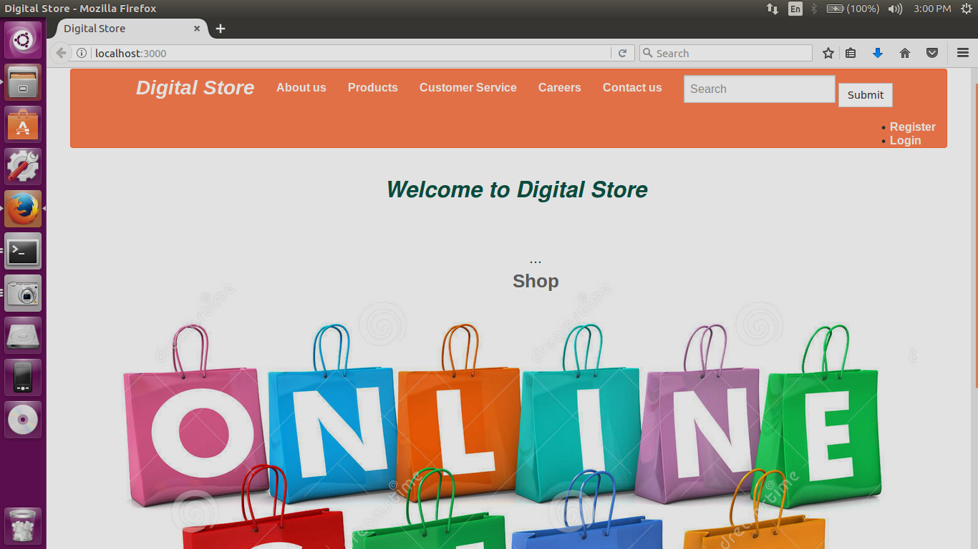

**‘About us ‘ page :**

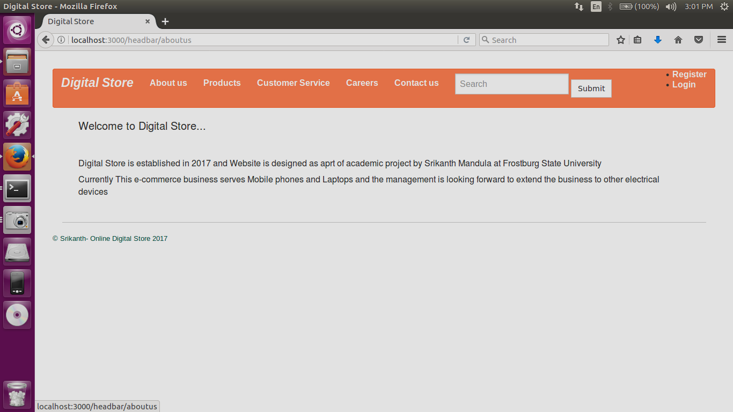

**‘Products’ page :**

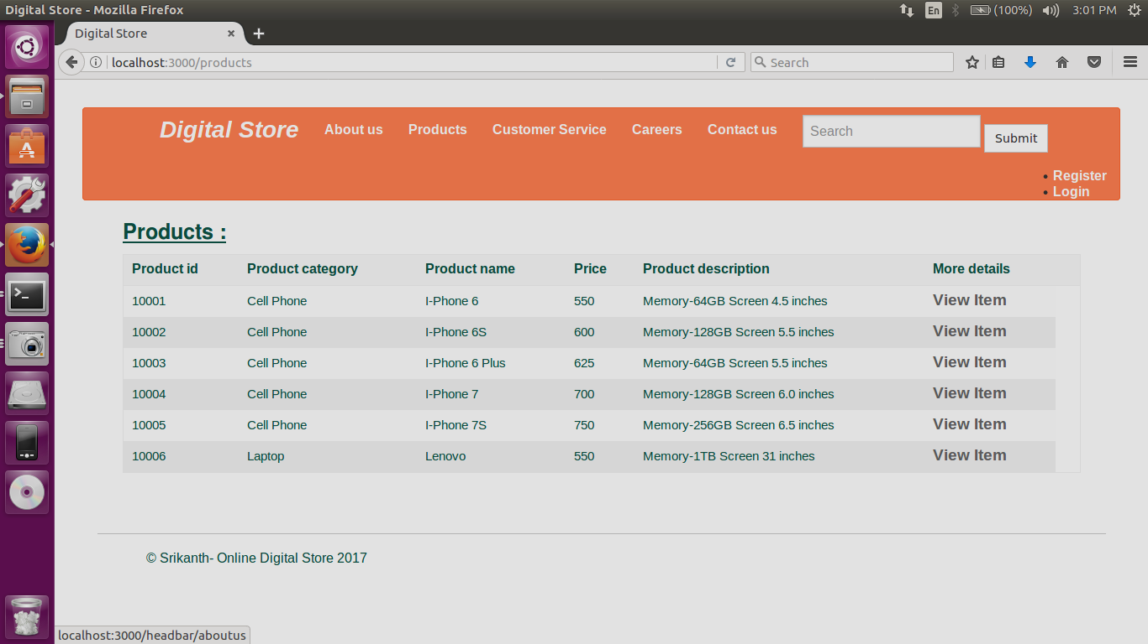

**‘Customer Service’ page :**

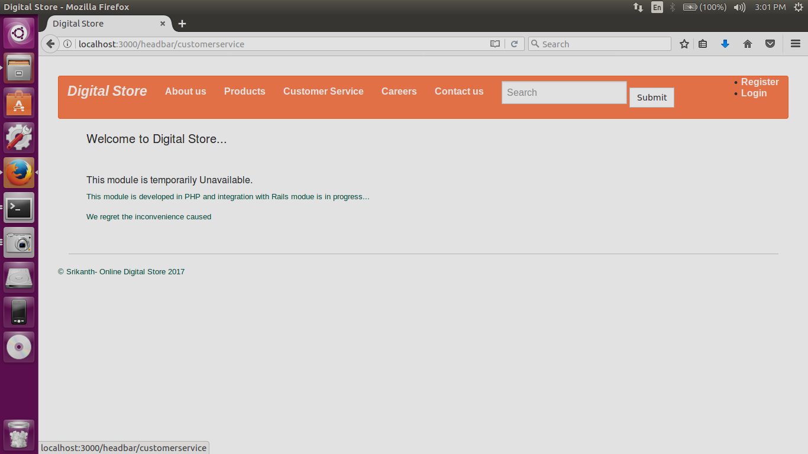

**‘Careers ‘ page :**

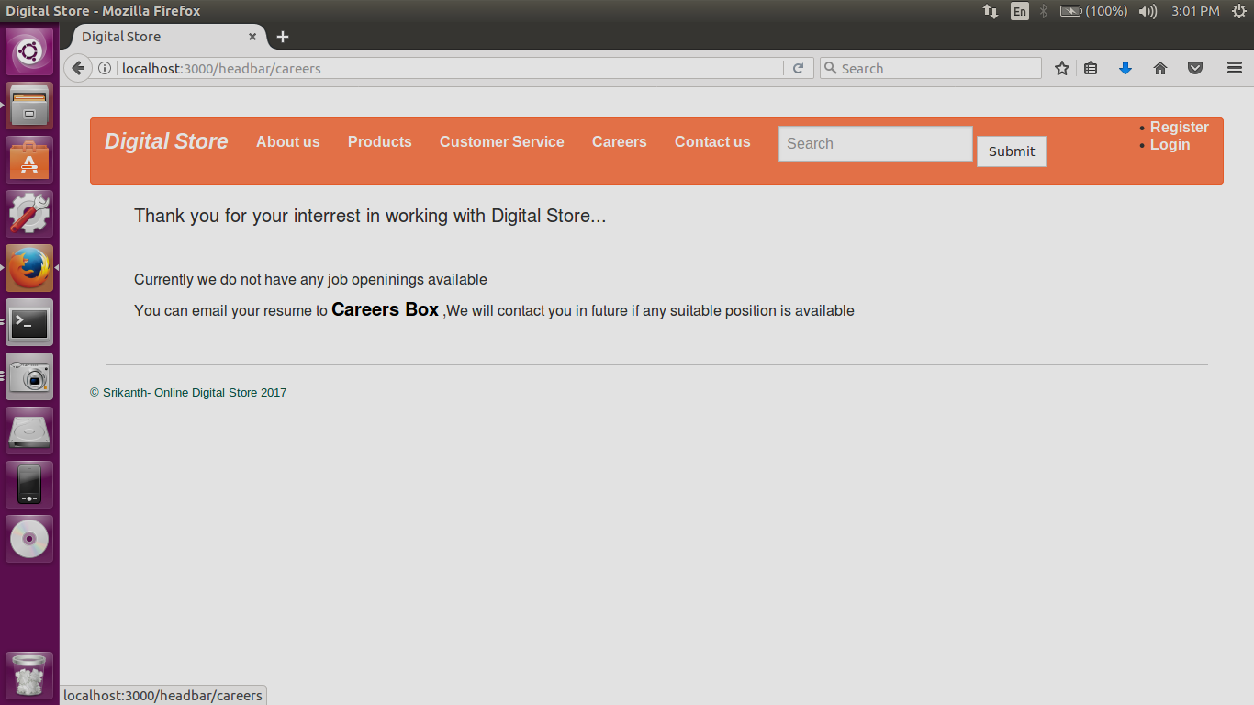

**‘Contact us’ Page :**

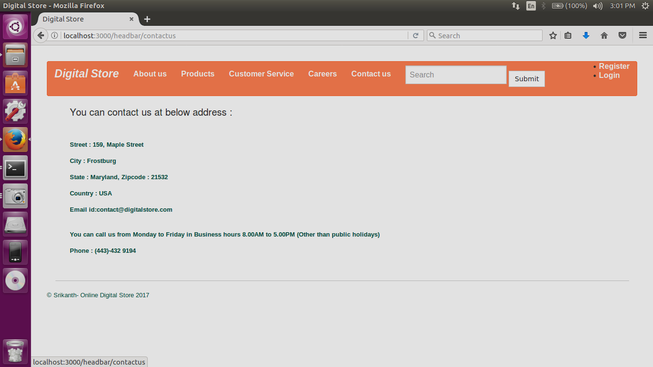

**‘Log in’ Page :**

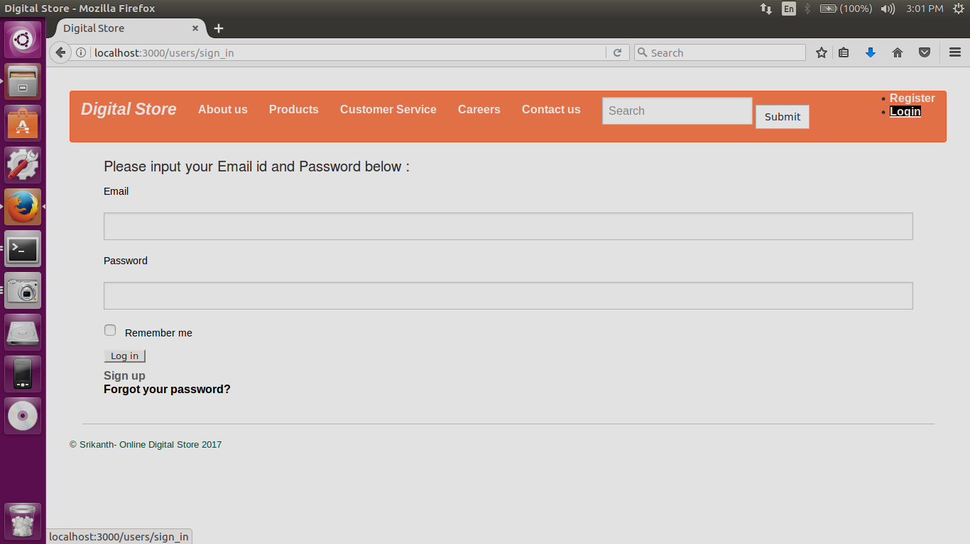

**‘User Welcome ‘ page :**

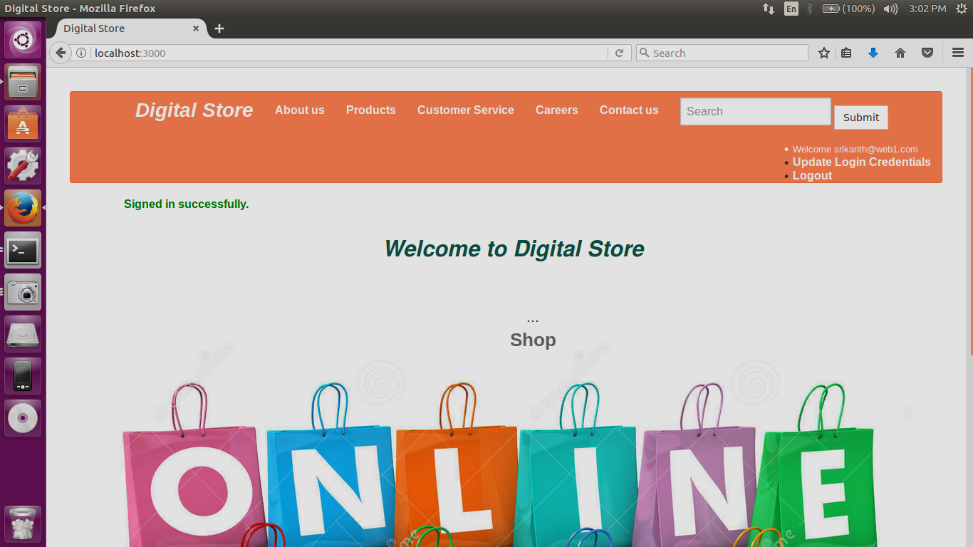

**‘Products’ page :**

(Can be accessed by clicking **shop button** or by clicking **Products tab** in the above image)

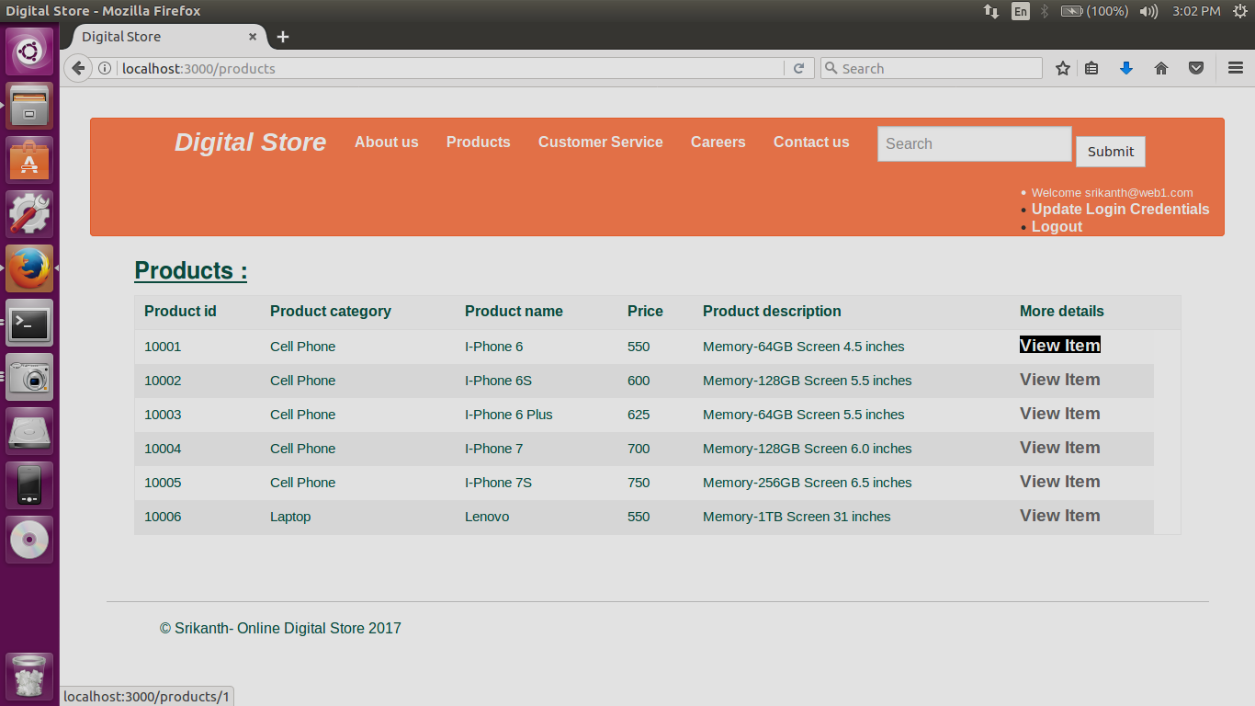

**‘ Details about Product ‘ :**

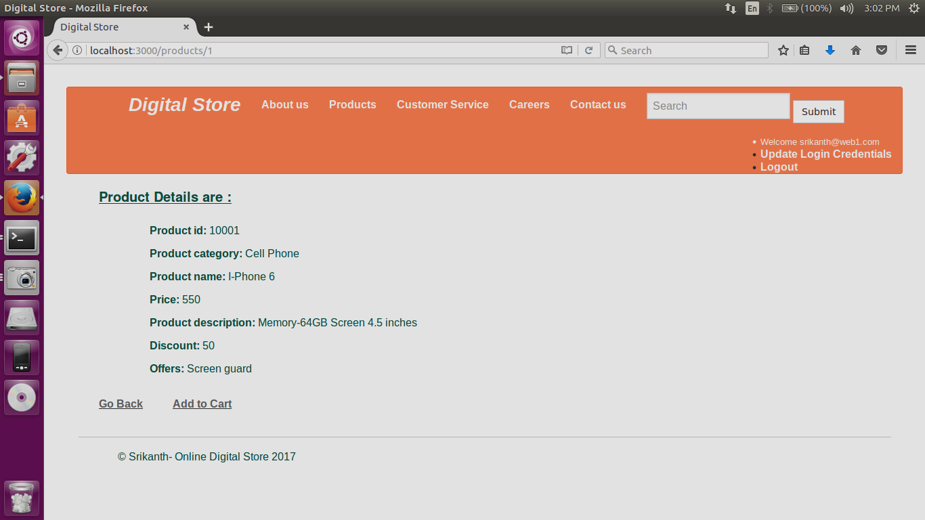

**After Clicking Add to Cart :**

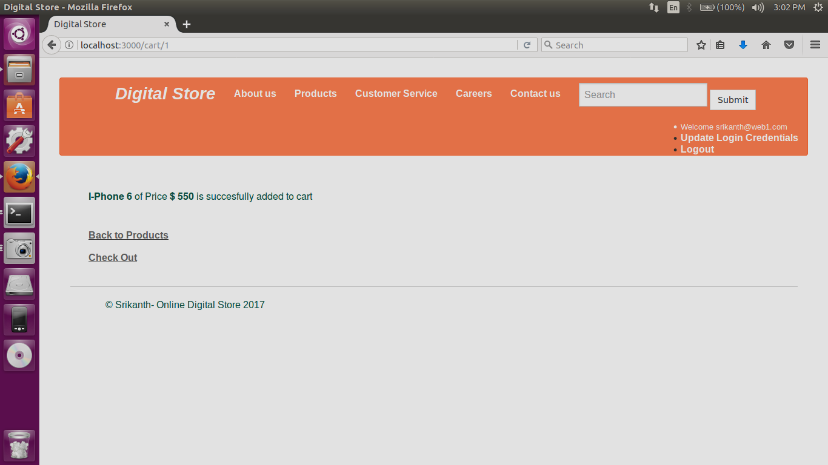

**After clicking Checkout :**

(It prompts for dispatch address and Payment details )

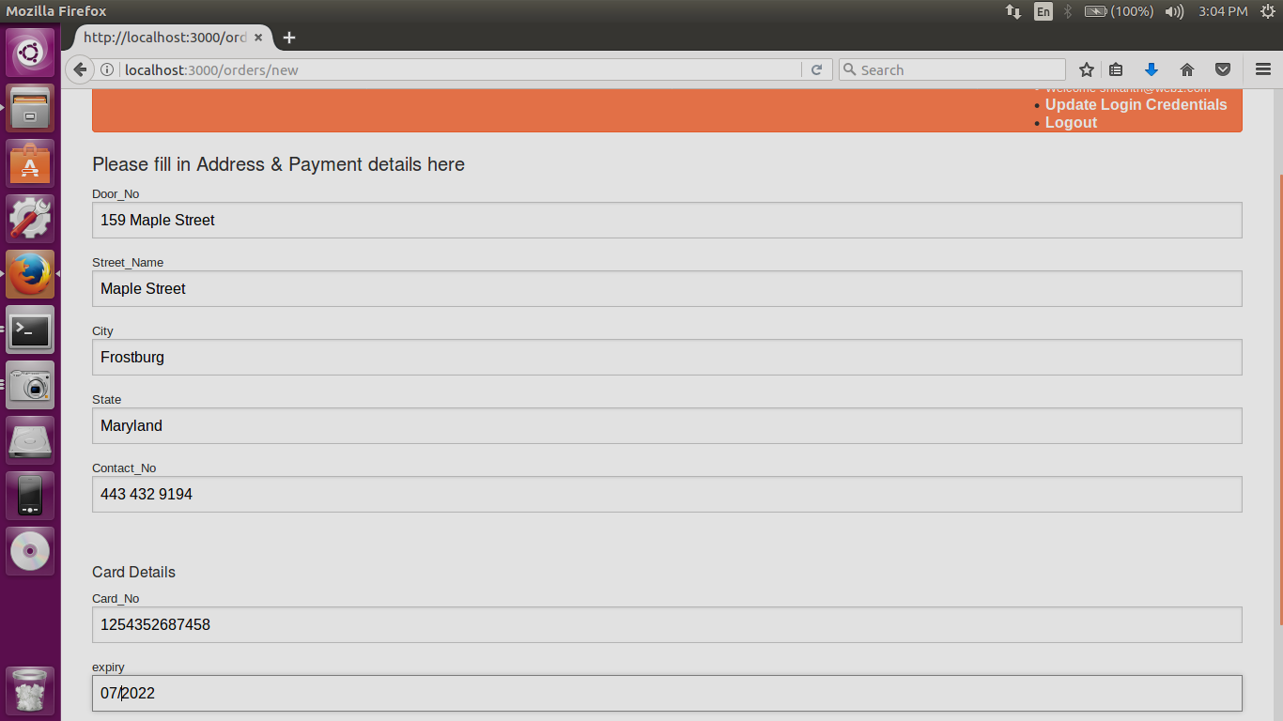

**Order Confirmation Page :**

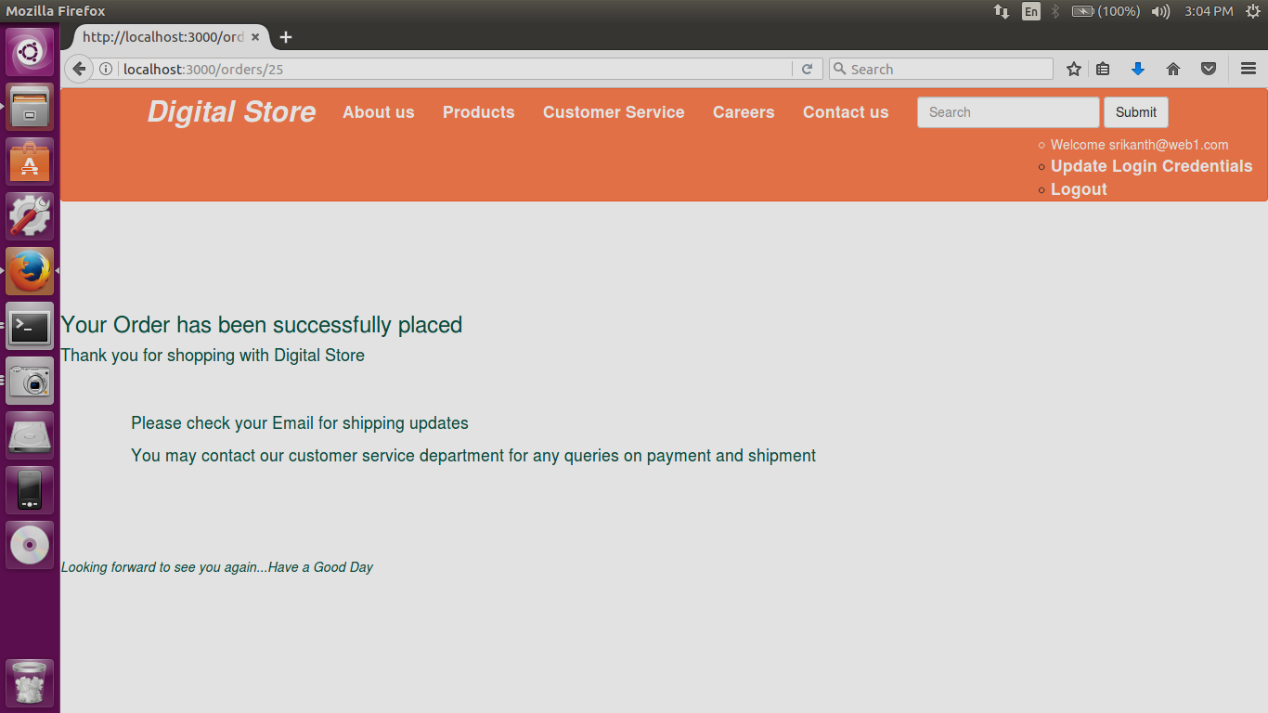

**Updating user credentials page :**

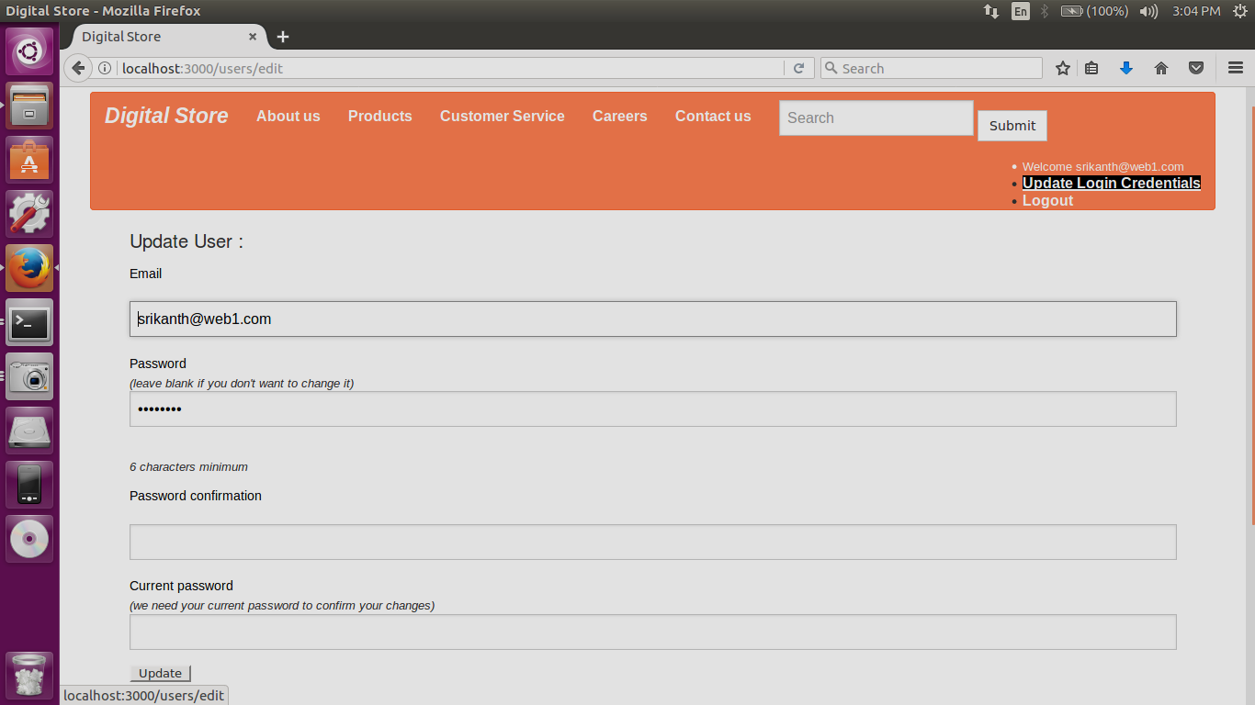

**Sign Out Page :**

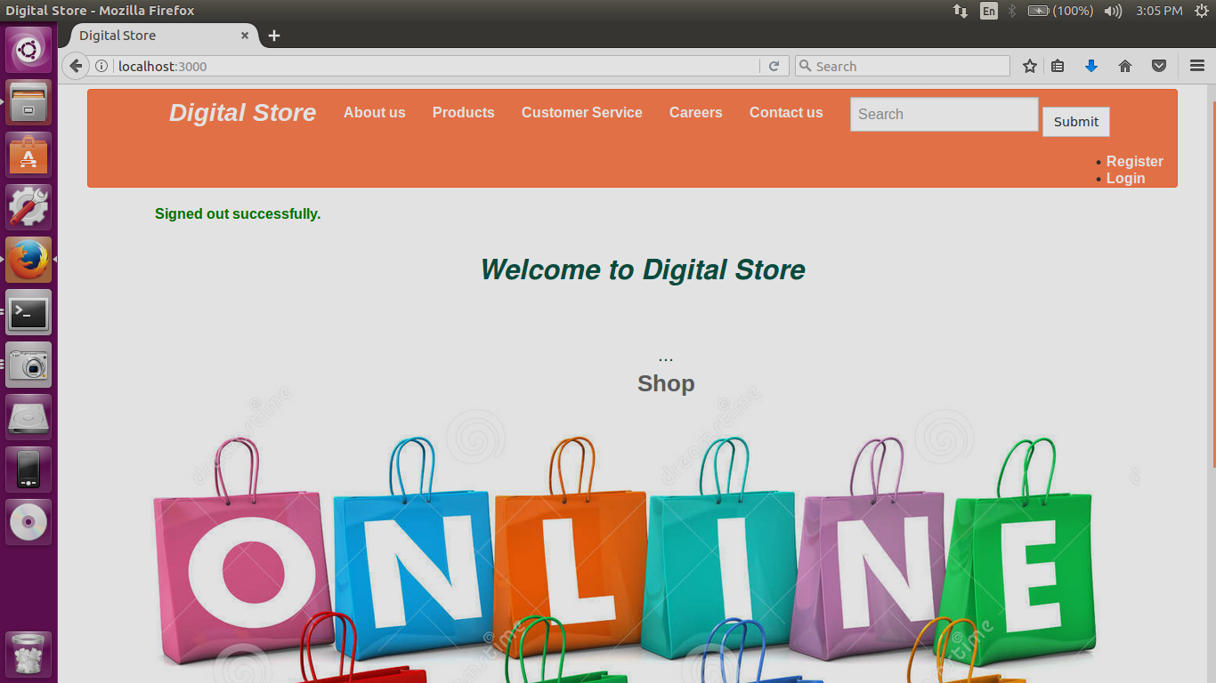

**Screenshot of PHP Code : ( PHP Program is uploaded at PHP Link)**

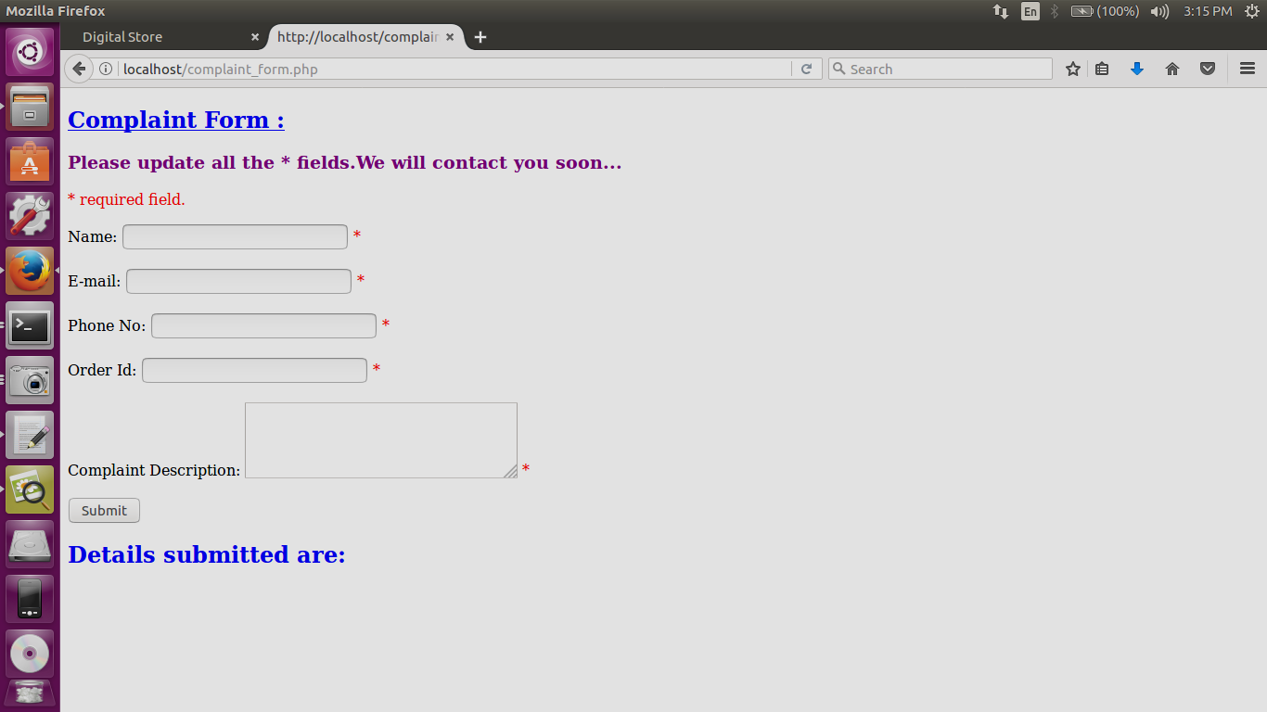

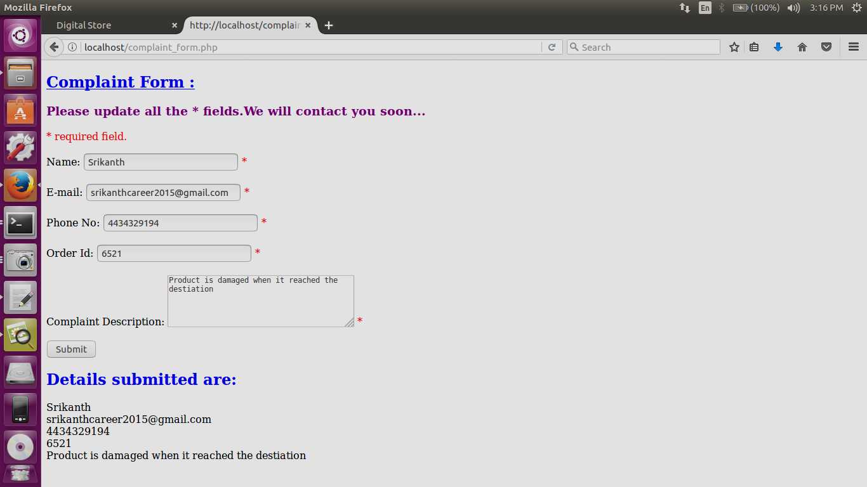

**PHP Validation screen shot :**

